Russell Andlauer

CS-2810

October 2, 2014

Assignment #5

3.12)

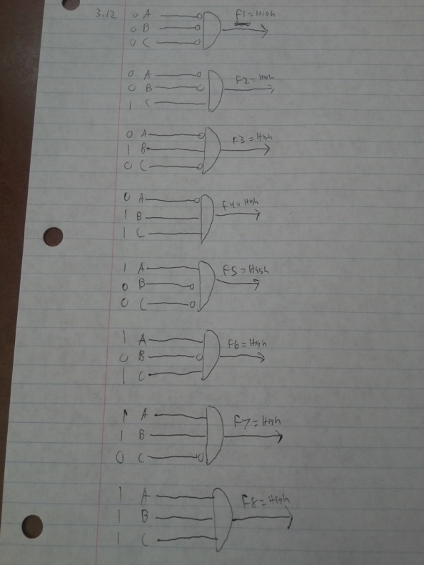

3.13) A five input decoder has 32 output lines.

3.14) A 16-input multiplexer will have 4 select lines in the output

3.15)

|  |  |  |  |  |
| --- | --- | --- | --- | --- |
| Cin | 1 | 1 | 1 | 0 |
| A | 0 | 1 | 1 | 1 |
| B | 1 | 0 | 1 | 1 |
| S | 0 | 0 | 1 | 0 |
| Cout | 1 | 1 | 1 | 1 |

3.19) Logic circuit 1 is combinational, logic circuit 2 is sequential.

3.21) There are 215 nibbles of storage in this memory.

3.22)

|  |  |  |  |  |  |  |
| --- | --- | --- | --- | --- | --- | --- |
| I4 | I3 | I2 | I1 | S1 | S2 | O1 |
|  |  |  |  | 0 | 0 | I1 |
|  |  |  |  | 0 | 1 | I2 |
|  |  |  |  | 1 | 0 | I3 |
|  |  |  |  | 1 | 1 | I4 |

3.24) The value of X on the wire acts as a switch

If X = 0 then A + B

If X = 1 then A + C

3.31) The total size of memory is 64 bytes, if the computer has 8-byte addressability and needs 3 bits to access a location of memory

3.34) a. The address space is 3

b. The addressability is 4 bits

c. The data at address 2 is 0001

3.35) There are 12 Megabits of storage in memory that is addressed by 22 bits and is 3-bit accessable. 12 Megabits is equal to 3 x 222 bits.

3.44)

